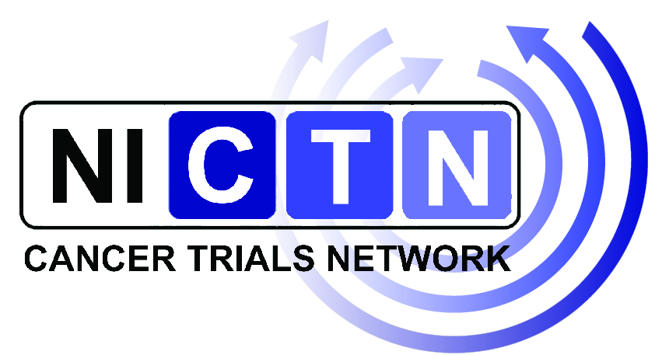
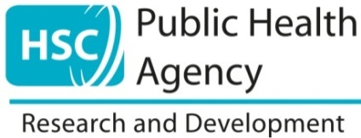

Involving the Public in the Design and Conduct of Research:
Building Research Partnerships
A workshop for Researchers & Members of the Public
17th October 2019

What is it?
This free workshop will look at practical ways to involve patients and the public as partners (PPI) in the research process. It will explore the issues related to becoming and being a member of the public involved in research and the role of researchers in facilitating this involvement.
Examples of what public involvement in research is not……
engaging and creating a dialogue with the public….. recruitment of patients or members of the public as participants in research
INVOLVE

Examples of public involvement in research……
working with research funders to prioritise research, offering advice as members of a project steering group, commenting on and developing research materials, undertaking interviews with research participants
INVOLVE

Who is it for?
Patients, carers and members of the public who are interested in getting involved in research and researchers interested in involving patients, carers and the public in their research.

How long is it?
1-day workshop from 9.30am until 4.00pm

What will I get out of it?
- As a patient, carer or member of the public, you will gain an understanding of what it means to be involved in research at each stage of the research process.

- As a researcher, you will gain an understanding of how patients, carers and the public can get involved in research, practical tips, the opportunity to share your research expertise and build research partnerships.

When and where?
This workshop will take place on the 17th October 2019, Grosvenor House, Glengall Street, Belfast

Registration:
To register your interest for this workshop please contact: cara.mcclure@hscni.net or Tel: 028 9536 3399 by 4th October 2019.

Places will only be confirmed after the closing date.

Reviews from Past Participants

‘I have met more individuals from all levels here today than I have in the last seven years. I feel more focused and motivated, thank you’

‘The organisers are very informative and easy to listen to. Enjoyed meeting other researchers’

‘Very interactive and engaging’

‘All areas of the course were of value because it gave insight into researchers’ and public’ perceptions’

Further Information on PPI in Research

http://www.research.hscni.net/sites/default/files/strategy_for_PPI_Report_RD_2014.pdf

http://www.qub.ac.uk/research-centres/media/Media,244007,en.pdf

