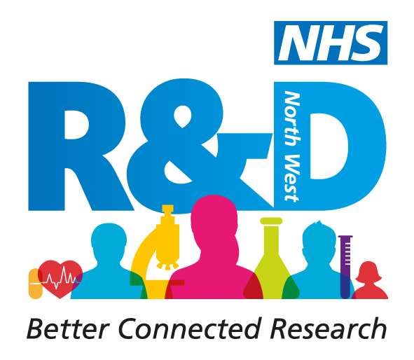

FREQUENTLY ASKED QUESTIONS 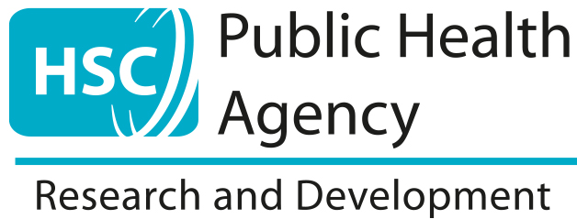

Who is eligible to apply?
Details of the eligible professions for the Bridging Scheme can be found here.

When do the applications for the Bridging Scheme open?
Applications for the 2022/23 cohorts opened on 11th July 2022.

When will the application process close?
Applications for the 2022/23 cohort close at 5pm on 26th August 2022.

How do I apply?
To apply please complete the relevant application form for the Bridging Programme, shortlisted candidates will then be invited to an interview. Please ensure you also submit your CV.

**Please note that interviews will be scheduled for September 2022 - specific dates TBC once shortlisting has taken place.

HSC R&D Pre Doctoral Bridging Scheme 2022-23 – Application Form and Guidance Notes

Do I need my manager’s support?
Applications for the Bridging Scheme will only be accepted with a signed statement of support from your line manager and an additional signature from a Senior Manager. This statement of support from your manager is included as part of the application form.

What time commitment is needed?
For the Bridging Scheme you will need to commit up to 50% of your contracted hours to focus on the development of your research career and work towards a successful fellowship application. Attendance at the workshops will be mandatory; these dates are fixed and cannot be changed. You will be notified in advance of these dates.

The protected time that you are released from your clinical work is to be negotiated with your line manager and advice can be given on how best to manage this. Your study days can be flexible and negotiated with your academic supervisor and employer.

How does the funding for my course costs and single payment work?
There will be no requirement for you to pay any fees associated with the Bridging Scheme.

A single payment of up to £10,000 will be paid direct to your employing trust once the scheme begins.

The payment is a contribution towards your salary and incidental costs; education, training and support costs, travel expenses and other reasonably incurred expenses by the awardee. We are aware that in some circumstances this funding will not be enough to cover expenses as well as salary support. In these circumstances there will be an expectation, in support of your application, that your employing trust will subsidise any shortfall. Alternatively, awardees can calculate how much of their contracted hours the payment will “buy” and negotiate this time with their employer. Advice can be given on how best to approach this with your line manager.

Is the initial residential workshop optional?
The initial workshop will be over 2 days and the overnight residential is optional. Attendance at the workshops during the day is mandatory but the awardees do not have to stay overnight. The cost for anyone staying over night and the group evening meal will be covered by the organisers.

Do I gain a qualification from this?
The Bridging Scheme is a preparation programme that develops your skills and knowledge in advance of a fellowship/doctoral application. There isn’t an official qualification awarded at the end of the programme, however it is a good addition to your CV.

What are the benefits for my employer?
The Bridging Scheme supports the national agenda to increase the capability of non-medical clinicians to contribute to the improvement of patient outcomes and innovations in healthcare. Individuals undertaking the scheme will start to develop the skills and knowledge required to undertake their own clinical research and progress along the clinical academic career pathway.

For more information, please see the NIHR ‘building a research career handbook: a guide for aspiring clinical academics (excluding doctors and dentists) and their managers’ which is available here.

What can I expect from my supervisor?
Any awardee without a supervisory team in place will receive support and guidance in finding a named academic supervisor and/or supervisors for the duration of the programme

Supervisors will be sought from across both the regional universities and trusts.

A matching scheme approach will be taken to ensure each awardee is matched with the optimal supervisor and will take account of both areas of interest as well as practical considerations

What happens after the programme?
The scheme will assist you to develop the skills and knowledge required to apply successfully for the next stage of the clinical academic pathway (e.g. HSC R&D Doctoral Fellowships Scheme, NIHR Doctoral Fellowship Awards). Support and guidance on options for further academic study or clinical academic careers will be provided.

After completing the programme, you will also become a member of our network providing you with further opportunities and support.

Further information

If your question has not been addressed on this page or you require further clarification, please contact the team on the details below.

sorcha.finnegan@hscni.net

