EVENT PACK

CONTENTS

- Event outline template (To be completed and returned to the PPI team by 13th September 2019)
- Event Ideas
- Event Checklist
- Attendance Sheet
- Event poster (To be added)
- Monitoring form (To be added)
- Evaluation form (To be added)
- GREAT Checklist (Service user / Carer and Staff)

Event Template
Event Name
Date
Time
Location / Venue
Event Details
(Please keep to a minimum of 50 words)

How to get involved?
Contact Details
Attachment | If you wish, you may attach a picture / logo or image related to your event for the Involve Fest brochure (send as a separate jpeg attachment with your event outline). (We cannot guarantee these images will be utilised however we will do our best to include).

Please return your completed form to: engage@hscni.net by 5pm on 13th September 2019. Late submissions will not be accepted.
For more info, contact bronach.mcmonagle@hscni.net or marie-claire.peters@hscni.net

Ideas
Coffee Morning | Service Open Day
Team Building day (Staff / Service Users & Carers) | Human Library
Poster/Video Competition | Workshops and Focus groups
Community style Fêtes | Story Telling event
Debates | Showcase PPI through the medium of Art / Music
Appreciation events | Launch of PPI Materials / initiatives
Training / awareness raising sessions | Community Engagement
Mini-Documentary/Showcase | Social Media Blitz in your local area
Create a PPI Toolkit | Young People and PPI event / initiative

Events Checklist
TASK | RESPONSIBILITY | DATE TO BE COMPLETED | COMMENTS
Appoint an Event Coordinator and Events Team
Decided on the theme and objectives of your event
e.g. target audience
Consider how to Engage Service Users and Carers in the planning of your event (See Guides for involvement at http://engage.hscni.net/get-involved/involving-people/guides-to-personal-and-public-involvement/quality-improvement/
Think about your budget/time/location
Consider the commitment of staff/volunteers
Book a venue
Prepare an Invite List
Set up a registration system for attendees
Organise your equipment
Organise your catering – remember to consider dietary requirements
Organise and print an event programme e.g. Book speakers/contributors
Promote your event e.g. Social media, print etc.
Prepare any literature/promotional materials/event signage
Logistics e.g. Ensure venue is fully accessible, audio/visual equipment in place, seating
Any additional housekeeping e.g. decorations
Prepare evaluation and monitoring forms to capture impact and outcomes.

Name of event:
Date and time:
Venue:

Attendance Sheet
NAME | ORGANISATION | CONTACT DETAILS | SIGNATURE
GREAT CHECKLISTS – SERVICE USER / CARER
http://engage.hscni.net/wp-content/uploads/2018/10/020204-HSC-HSCQI-Great-Leaflets-Service-Users.pdf

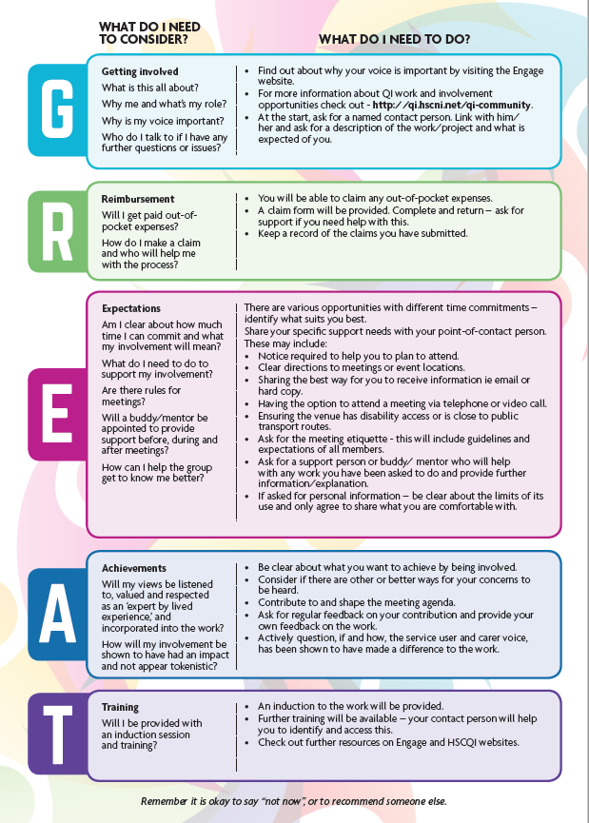

GREAT CHECKLISTS – STAFF
http://engage.hscni.net/wp-content/uploads/2018/10/020204-HSC-HSCQI-Great-Leaflets-Staff.pdf

