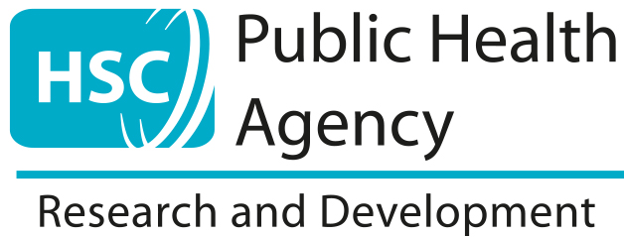

Role Description of PIER Members/PPI Representatives
In HSC Research & Development Division,
Public Health Agency (HSC R&D)

Background

Health and social care research aims to help improve health and wellbeing by increasing our understanding of the diagnosis, treatment, prevention and how best to support people. If we are to improve health and social care we need more knowledge and more innovation in the application of knowledge.

HSC R&D was established in 1998 to support and encourage health and social care research & development in Northern Ireland through direct funding for research studies as well as investment in training and infrastructure to build local capacity for research.

This document sets out the roles and responsibilities for the PPI Representatives/Public Involvement Enhancing Research (PIER) NI members who work in partnership with HSC R&D Division, Public Health Agency to implement Patient and Public involvement in HSC Research in Northern Ireland.

Responsibilities

It is not intended that the PPI representative/PIER member will represent any group of patients or organisation but will lend his/her individual perspective as a member of the general public or a patient, client or carer with experience of a particular illness, condition or service.

The PPI representative/PIER member may be asked to:

- sit on research funding award panels
- attend meetings of committees/groups
- review research documents
- take part in research steering groups
- respond to consultations
- undergo relevant training
- assist researchers with grant applications
- assist with PPI training for researchers

Through these activities he/she may be asked to give views on the:

- topics researchers are studying
- research questions they are asking
- wording of patient information sheets
- methods of recruitment of patients or clients to research studies
- burden/impact of a participant taking part in a study
- value for money of a study
- the way in which the research findings are being shared

Terms of Reference

PPI/PIER representatives on R&D panels are asked to:

- bring their own experience as a service user, carer or member of the general public to assist the panel in understanding the perspectives of service users and the public that are relevant to the discussion, particularly in relation to the PPI plan
- not act as a representative of any particular group or body
- contribute to the discussions which guide the panel’s decisions and recommendations
- comment on the transparency and fairness of panel discussions
- prepare for the panel by reading papers before the meeting and raising any issues for clarification with the Chair
- keep confidential any information that they acquire as a result of being a member of the panel
- identify any personal needs for training and support
- participate in any evaluation of this role or the activities of the panel

Support

HSC R&D will ensure the provision of an ongoing programme of support which will be tailored to individual needs for PPI representatives/PIER members. This may include:

- a named point of contact
- induction
- mentorship
- training e.g. in the research process/being heard
- travelling expenses and subsistence
- written guidance
- study days
- visits to Research Centres
- other activities identified by PPI representative/PIER member

Person Specification:

Essential Attributes
- an interest in and commitment to improving health and social care
- an ability to listen to others and express views in a polite but effective manner

Desirable Attributes
- knowledge and experience of a specific illness or social care context
- confidence to discuss issues with health and social care professionals, as well as the public and patients, carers and service users
- knowledge or experience of the research process
- experience of taking part in meetings or panels
- experience of reading documents and providing feedback (either written or though discussion)

