


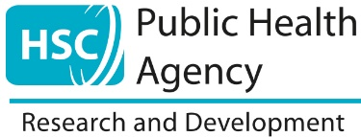
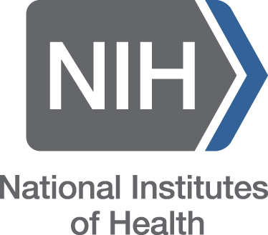


US-Ireland R&D Partnership Programme (NIH stream)
Draft Tri-Partite Proposal Submission
Mandatory “Intention To Submit” (ITS) Form

For Republic of Ireland (RoI) applicants, please complete the relevant sections and submit in the form of an Adobe pdf document to usireland@researchireland.ie.

For Northern Ireland (NI) applicants, please complete the relevant sections and submit in the form of an Adobe pdf document to USIreland@hscni.net.

This form must be submitted to the relevant funding agencies, North and South, via the Research Body Research Offices of the RoI and NI lead applicants respectively at least 10 weeks in advance of the full proposal deadline at NIH.

Section 1: Contact Details and eligibility of applicants/co-applicants
Please copy and paste the below information as required for co-applicants
RoI Applicant Contact Details
Title: Click or tap here to enter text.
Name: Click or tap here to enter text.
Department:Click or tap here to enter text.
Institution:Click or tap here to enter text.
Telephone Click or tap here to enter text.:
Email:Click or tap here to enter text.
Eligibility:
(i) Contract status Click or tap here to enter text.
(ii) Qualifying research award: awarding body, grant title, grant #, funding period Click or tap here to enter text.
(iii) Year PhD awarded Click or tap here to enter text.
(iv) If you currently hold a US-Ireland award, when did the award commence? Click or tap here to enter text.

NI Applicant Contact Details
Title: Click or tap here to enter text.
Name: Click or tap here to enter text.
Department: Click or tap here to enter text.
Institution: Click or tap here to enter text.
Telephone: Click or tap here to enter text.
Email: Click or tap here to enter text.
Eligibility:
(i) Contract status Click or tap here to enter text.
(ii) Qualifying research award: awarding body, grant title, grant #, funding period Click or tap here to enter text.
(iii) Year PhD awarded Click or tap here to enter text.
(iv) If you currently hold a US-Ireland award, when did the award commence? Click or tap here to enter text.

US Applicant Contact Details
Title: Click or tap here to enter text.
Name: Click or tap here to enter text.
Department: Click or tap here to enter text.
Institution: Click or tap here to enter text.
Address: Click or tap here to enter text.
Telephone: Click or tap here to enter text.
Email: Click or tap here to enter text.

Section 2: NIH Institute and Programme details
Target NIH Institute: Click or tap here to enter text.
NIH R01 (or equivalent) programme FOA: Click or tap here to enter text.
Submission Deadline: Click or tap here to enter text.

Section 3: Application overview, proposed topic, title of proposal, abstract
Proposed Topic: Click or tap here to enter text.
Title of proposal: Click or tap here to enter text.
Abstract (max 250 words): Click or tap here to enter text.
ROI: Highlight area of speciality which the ROI partner is contributing to the proposal:
Click or tap here to enter text.
Indicative total direct costs likely to be requested for ROI (€): Click or tap here to enter text.
NI: Highlight area of speciality which the NI partner is contributing to the proposal: Click or tap here to enter text.
Indicative total direct costs likely to be requested for NI (£): Click or tap here to enter text.
US: Highlight area of speciality which the US partner is contributing to the proposal Click or tap here to enter text.
Indicative total direct costs likely to be requested for US: Click or tap here to enter text.

